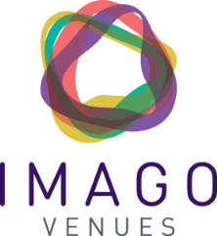

Imago Venues Gender Pay Gap Report
Following the Equality Act 2010 Regulations 2017 we are happy to report our gender pay gap figures.
Imago Venues recognise the importance of our staff, and realise that our reputation is dependent on their hard work and excellence. We are therefore committed to ensuring that people are paid fairly for the work that they do and to ensuring that all staff are empowered to operate at their highest levels.
The Gender Pay Gap is a concept that measures the difference between the pay of men and women regardless of the roles. Equal Pay measures pay between men and women in work of ‘equal value’. Both have helpful purposes but are different concepts and we strive to ensure equality of opportunity for all our staff regardless of gender and seek to develop a demonstrably fair and supportive environment which provides equality of opportunity and freedom from unlawful discrimination.
We take our equal pay obligations very seriously and induction training in equal opportunities and diversity is mandatory for all staff. Our gender pay gap results demonstrate a relatively small difference between male and female pay at Imago.
The gender pay gap shows the difference in the average pay (median and mean) between all men and women at Imago on the 5 April in a given year. The data for April 2020 is as follows:
Mean gender pay gap: Women's hourly rate is 1.40% lower
Median gender pay gap: Women's hourly rate is 4.96% lower
Proportions of men and women in each mean hourly rate quartile pay band:
Quartile | Men | Women
Top (highest paid) | 43.1% | 56.9%
Upper middle | 35.4% | 64.6%
Lower middle | 27.3% | 72.7%
Lower (lowest paid) | 30.3% | 69.7%
Mean bonus pay: Women’s bonus pay is 14.4% lower
Median bonus pay: Women’s bonus pay is 10.0% lower
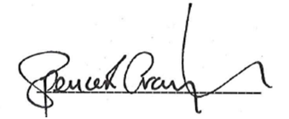
Proportion receiving bonus: Men – 43.8% Women – 37.6%

Spencer Graydon - Chief Executive

